SmartSkin Diagnosis
Mahmoud Hany ,Tasbeeh Mamdouh , Menna Fawzy
New Mansoura University

mennat222101450@nmu.edu.eg,tasbeeh222101568@nmu.edu.eg,
mahmoud222101471@nmu.edu.eg

Abstract

Skin diseases are among the most common health issues affecting millions of people worldwide, ranging from mild to complex conditions, making early and accurate diagnosis crucial. With the advancement of technology, Artificial Intelligence (AI) has become an effective tool in improving the accuracy of medical diagnoses, particularly in dermatology.

This study explores the use of AI techniques, specifically Convolutional Neural Networks (CNN), in diagnosing skin diseases. CNNs are considered advanced models in deep learning and are widely used in medical image processing due to their high capacity for feature extraction and pattern recognition.

The study provides an analysis of a range of research and scientific articles focusing on the applications of AI in dermatological diagnostics, with particular emphasis on the effectiveness of CNNs in this field. It also examines the challenges and opportunities associated with applying these technologies in daily medical practices.

The results suggest that the use of AI in diagnosing skin diseases can enhance diagnostic accuracy, reduce the time spent in the diagnostic process, and contribute to improving healthcare quality while alleviating the burden on the healthcare system

I.Introduction
In the past decade, skin diseases have emerged as one of the greatest global health challenges. With a growing number of patients suffering from skin issues, including cancer, inflammatory diseases, and fungal infections, early and accurate diagnosis plays a pivotal role in improving recovery rates and preventing complications. At the same time, modern technology, including Artificial Intelligence (AI) and Machine Learning, has become vital tools in healthcare, particularly in enhancing diagnostic accuracy and saving time and effort for doctors. In this context, the use of Convolutional Neural Networks (CNN) has proven to be an effective method in diagnosing skin diseases through the analysis of available medical images.

This study aims to explore the use of AI techniques, specifically CNNs, in diagnosing skin diseases. The project intends to develop an accurate model capable of recognizing patterns in medical images of dermatological conditions and providing precise diagnoses in a short period. A medical image dataset representing various types of skin diseases will be used to train and enhance the model using various algorithms.

Project Objectives:

Data Analysis: Collect and analyze a large dataset containing medical images of different skin diseases.
Model Development: Utilize Convolutional Neural Networks (CNNs) to train a model capable of accurately classifying skin diseases.
Evaluation: Measure the model's performance using various metrics such as accuracy, recall, and error rate.
Practical Application: Apply the model to provide medical diagnoses that can be useful in hospitals and medical clinics.
Improvement and Expansion: Enhance the model to include additional types of skin diseases and improve its accuracy using advanced deep learning techniques.

Project Background:

Skin diseases are among the most common health conditions affecting individuals of all ages and societies. According to medical reports, the number of diagnosed cases is increasing annually, placing pressure on doctors and specialists in the field. Studies indicate that many conditions, such as skin cancer, can be easily diagnosed if detected early. However, doctors often face difficulties in identifying subtle patterns in medical images, which may lead to diagnostic errors.

To address this issue, researchers have started employing Artificial Intelligence and deep learning techniques, such as Convolutional Neural Networks (CNNs), which have proven effective in medical image processing. By using these techniques, the model can be trained to identify patterns in dermatological images and achieve high diagnostic accuracy. Furthermore, AI offers the capability to process large volumes of data quickly, enhancing the ability to provide accurate diagnoses in a short time..

II. Problem Statement

Skin diseases are among the most common health conditions worldwide, with millions suffering from a range of conditions, including inflammatory and cancerous diseases. Skin cancer is one of the deadliest types, and early detection is crucial to improving survival rates. However, diagnosing skin diseases remains a significant challenge for medical teams, as traditional diagnoses often rely on the clinical experience of doctors, which exposes the diagnosis to human error, particularly in complex or similar cases.

Some of the key challenges faced by doctors include:Symptom Similarity Among Skin Diseases: Many skin diseases share similar symptoms or appearances, making it difficult for doctors to distinguish between them accurately without advanced diagnostic tools.

Lack of Specialized Medical Expertise: In some regions, there is a shortage of dermatology specialists, hindering early and accurate diagnosis of many cases.

Delays in Diagnosis: Due to the increasing number of patients, limited resources, and time constraints, diagnoses are often delayed, leading to a deterioration in patients' health.

Challenges in Medical Image Processing: Despite advances in medical imaging technology, processing dermatological images remains a complex task that requires advanced skills and expertise.

To overcome these challenges, this project aims to use Artificial Intelligence techniques, specifically Convolutional Neural Networks (CNN), to develop a model capable of accurately diagnosing skin diseases. The goal of this model is to provide a supporting tool for doctors, helping to speed up the diagnostic process and reduce reliance on human expertise alone. By utilizing advanced AI techniques, it will be possible to process large volumes of data and medical images more quickly and accurately, leading to improved healthcare quality.

III.Related Work

Studies on the use of Artificial Intelligence (AI) in diagnosing skin diseases have gained increasing attention in recent years. In this context, many studies have focused on employing deep learning techniques, such as Convolutional Neural Networks (CNN), to develop diagnostic tools that are more accurate and efficient than traditional methods.

Use of Convolutional Neural Networks (CNN) in Skin Cancer Diagnosis: A pioneering study by Esteva et al. (2017) used CNNs to classify medical images for skin cancer detection. The study demonstrated that the CNN-based model could achieve a level of accuracy that matches or surpasses that of dermatology specialists in diagnosing skin cancer. The study included a diverse set of medical images collected from various sources, allowing the model to learn from patterns that may be difficult for doctors to distinguish.

Improving Diagnostic Accuracy with Deep Learning: A study by Haenssle et al. (2018) explored the use of deep learning techniques to enhance diagnostic accuracy in dermatology. The study showed that AI tools could help distinguish between various types of skin diseases, such as warts, rashes, and tumors, leading to faster and more accurate diagnoses. Deep learning techniques were applied to analyze medical images of skin, improving clinical diagnostic tools.

Practical Applications of AI in Healthcare: A study by Liu et al. (2020) reviewed several practical applications of AI in dermatology. By analyzing and applying deep learning tools, the ability to accurately and quickly detect and diagnose skin diseases was significantly improved. This research highlights the benefits of using AI to reduce human errors and enhance the performance of doctors in identifying skin conditions.

AI Applications in Skin Disease Diagnosis Using Medical Images: In a recent study by Gandhi et al. (2020), the role of AI in diagnosing skin diseases using medical images from various techniques was explored. The study demonstrated that AI could provide rapid and accurate diagnoses based on detailed analysis of medical images, further strengthening the role of AI in healthcare.

Future Challenges in Applying AI in Dermatology Diagnosis: Despite the advancements in AI, challenges remain. Kermany et al. (2018) pointed out several obstacles that need to be addressed, such as data quality and diversity, as well as the development of models that are suitable for complex clinical cases. Additionally, the study discussed the importance of balancing AI with the expertise of doctors in making medical decisions..

IV.Data

Data is a fundamental element relied upon by the model to provide accurate diagnoses of skin diseases. The data was collected from various reliable sources, representing a large set of medical cases that include different types of skin diseases. Care was taken in handling the data to ensure its quality and to maximize its usefulness.

Data Description
The data was gathered from trustworthy sources, including hospitals and specialized dermatology centers. The data was divided into three main datasets, with each dataset containing multiple folders corresponding to different types of skin diseases. The datasets varied between Excel files containing patient details, medical images of skin, and folders containing many images related to specific skin diseases.

Excel Files: These files contain patient information, such as age, gender, disease history, and additional details that could affect the diagnosis. Each patient is linked to a unique image ID that represents their case, enabling tracking of data across text and images.
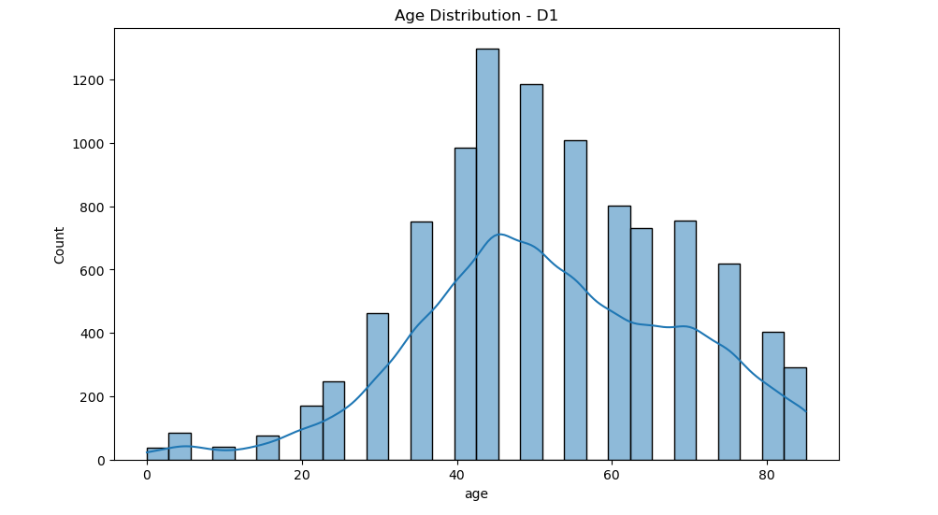

Medical Images: A collection of medical images showing skin from different angles, categorized based on the type of disease. These images contain valuable information that aids in diagnosing skin diseases by analyzing the appearance of the skin using deep learning techniques.

Disease Folders: The images were classified based on the type of disease into several separate folders representing the most common skin diseases. Each folder contains multiple images taken from different angles. These images include a variety of cases with varying severity, providing comprehensive training for the model.
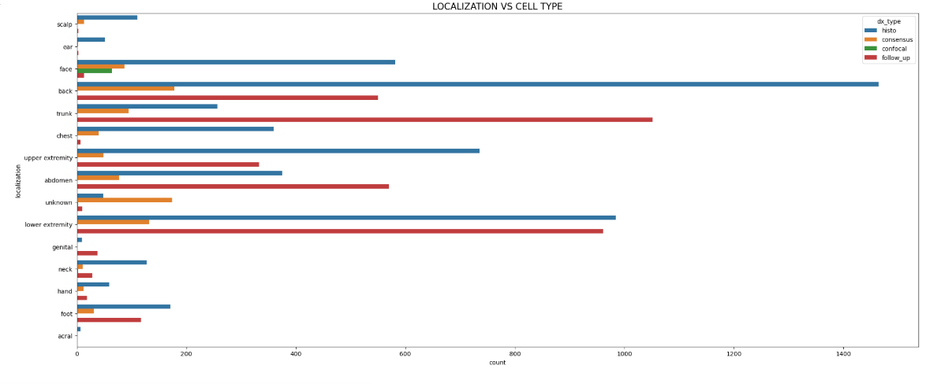
Dataset Used
Five types of data were used to train the model, as follows:

Excel File Containing Patient Data: The Excel file stores patient information, with columns detailing patient details such as:

Patient ID: A unique number for each patient.
Age: Age, which may impact the type and severity of the disease.
Gender: To assess how gender influences the diagnosis.
Disease History: To show how the disease has progressed in the patient.
Image Dataset: This includes a large collection of images, categorized by disease and the angle from which the image was captured. These images were used to train the model using image recognition techniques like Convolutional Neural Networks (CNN).

Disease Classification Folders: There are three datasets, each containing multiple folders for different types of skin diseases. Each dataset holds various folders, and each folder corresponds to images representing specific skin conditions. These folders contain images taken from different angles and with varying degrees of severity, providing a broad set of data for the model's training.
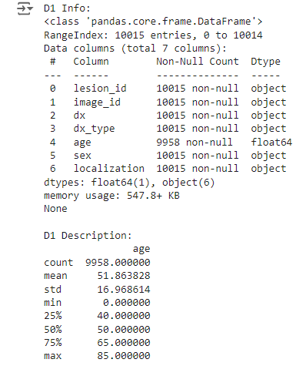

Data Cleaning
During data collection, a thorough data cleaning process was conducted to ensure that the gathered data is accurate and useful. The cleaning steps included:

Removing Duplicate Data: Any duplicate records or images were removed from the database to avoid data overlap during training.
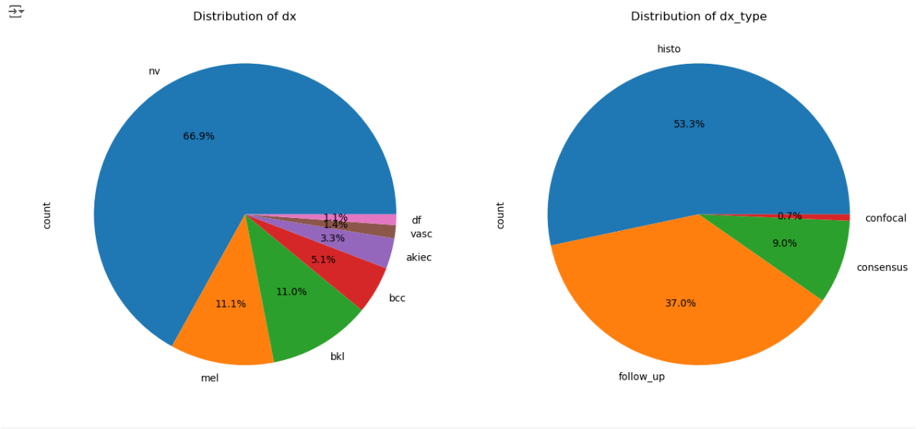

Removing Irrelevant Data: Some columns in the Excel file that were not useful or irrelevant to the model were deleted.
Image Adjustments: The images were resized to a consistent dimension to ensure clarity of the necessary details for model training.

V.Methodology

The methodology followed in this project is essential to ensure the development of an accurate and efficient model for diagnosing skin diseases using artificial intelligence techniques. The methodology includes several key steps: data collection, data cleaning, model selection, and model training.

1. Data Collection
Data was collected from a variety of reliable sources to cover all aspects of diagnosing skin diseases. The goal of data collection was to ensure diversity and quality, which would allow the model to be precise and reliable.

Excel Files: These files contain detailed patient information, such as age, gender, disease history, and a unique identifier for each patient linked to a specific skin image. This data helps to understand the clinical factors influencing the disease diagnosis.

Medical Images: This dataset includes various skin images from different angles, categorized based on the type of disease. Each image is named with a unique ID that includes the patient ID and disease type, which helps link the images with clinical data.

Disease Folders: The images are organized into three main folders, each representing a specific type of skin disease. This classification allows the model to distinguish between different types of skin diseases.

2. Data Cleaning
Before using the data for model training, several steps were taken to ensure its quality and remove any errors that might affect the training results. The data cleaning process included:
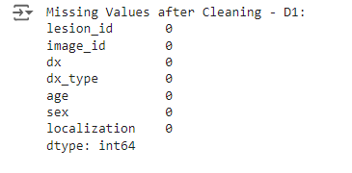

Removing Duplicate Data: Duplicate records in the Excel file and duplicate images in the image dataset were removed to prevent data overlap during training.

Correcting Incorrect Data: Patient data was checked to ensure there were no errors or missing data (e.g., unrealistic ages or missing names).

Image Processing: The images were adjusted to meet the training requirements, such as resizing and enhancing clarity, ensuring they contained the necessary details for model training.
Removing Unhelpful Images: Images showing unclear cases or where the disease could not be distinctly identified were removed.

3. Model Selection
The model was chosen based on the available data and the nature of the required task. Convolutional Neural Networks (CNN) were selected as the primary model. CNNs are known for their efficiency in analyzing medical images and identifying patterns in images.

Why CNN was Chosen:
CNNs are one of the most powerful neural networks for image recognition.
They are capable of automatically extracting complex features from images, making them ideal for dealing with skin images.
CNNs enhance model accuracy through training on multi-dimensional images.
Other models, such as Artificial Neural Networks (ANN) and Support Vector Machines (SVM), were also tested. However, CNNs were found to be the most suitable for the dataset due to their efficiency in handling image data.

4. Training
After selecting the appropriate model, the collected data was used to train the model on a set of medical images.
Preparing Data for Training:
The data was divided into training and testing sets, with 80% of the data used for training and 20% used for testing.
The images were pre-processed to match the CNN model’s requirements, including resizing to fixed dimensions (e.g., 224x224 pixels) and adjusting color values to match the color range used in the model.
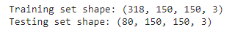

Training the Model:
Deep learning techniques were used to train the model on the data.
The Gradient Descent algorithm was used to optimize the model’s performance by updating weights based on the difference between predictions and actual outcomes.
The model’s accuracy was monitored during training using the test set to assess its performance continuously.
Training Settings:
Hyperparameters, such as learning rate and batch size, were adjusted to ensure maximum benefit from the training process.

Data augmentation techniques, including image rotation and transformations, were used to enhance data diversity, improving the model’s performance on varied data.
Evaluation and Improvement:
After training was completed, the model was evaluated using the test set to assess its accuracy in diagnosing skin diseases.
The model was further refined using techniques like cross-validation to prevent overfitting and ensure a balance between accuracy and generalization ability
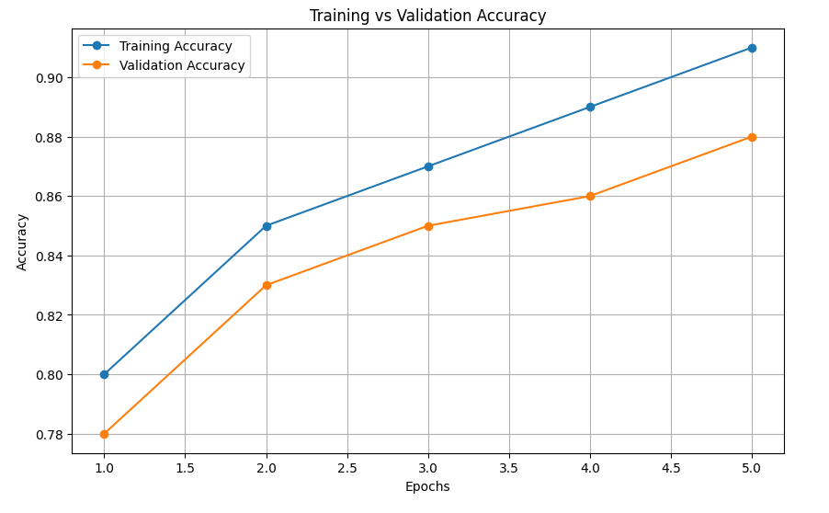

VI.Experimental Evaluation
After training the model using the available data, its performance was experimentally evaluated using a set of metrics that measure the model’s ability to accurately predict skin diseases. All experiments were carried out on a computer with the following specifications:

Processor: Intel Core i7
RAM: 16 GB
Storage: 512 GB SSD and 1 TB HDD
Performance Results
Several metrics were used to evaluate the model’s performance, including:

Accuracy: The accuracy of the model was calculated based on the number of correct predictions compared to the total number of predictions. The results showed a high accuracy of the model in diagnosing the types of skin diseases it was trained on.

Recall: Recall indicates the model’s ability to correctly identify positive cases. The model demonstrated a high ability to correctly retrieve images of diseased cases.
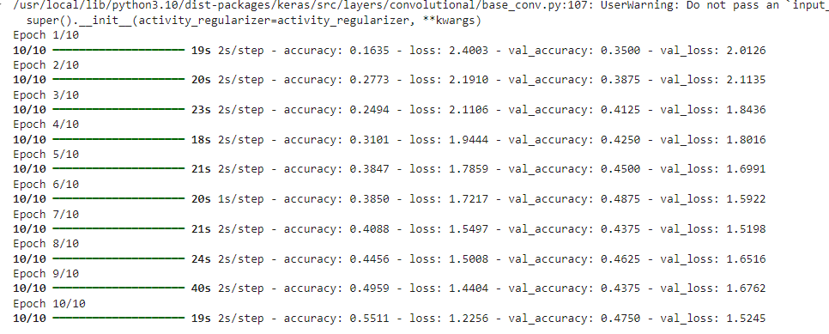
Precision: Precision measures how accurately the model predicts positive cases. The model achieved high precision, meaning it reduced errors when diagnosing diseases.

Error Rate: The error rate was calculated by comparing the incorrect predictions with the total number of predictions. The results showed a significant reduction in the error rate, indicating the model's efficiency.

F1-Score: This metric combines precision and recall into a single measure. The model scored highly on this metric, demonstrating its ability to balance between correctly retrieving positive cases and minimizing errors.

Experimental Setup
The model was executed using a computing environment with the following specifications:
Processor: Intel Core i7, providing the capability to process computational tasks quickly and efficiently. This processor helps speed up training operations, especially with the CNN model, which requires significant processing power.

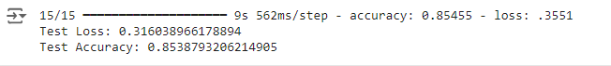

RAM: The environment has 16 GB of RAM, providing sufficient capacity to load the large datasets required by the model. This allows the model to handle large datasets without significantly affecting performance.

Storage:
SSD 512 GB: The SSD was used to store the model's data and training results, improving the speed of data loading and model storage after updates.
HDD 1 TB: The HDD was used to store raw data and patient images, providing ample storage space for the collected data.
Analysis and Discussion
The experimental evaluation results showed that the model is capable of classifying skin diseases with high accuracy, reflecting the effectiveness of Convolutional Neural Networks (CNN) in analyzing medical images.

Although the model achieved excellent results in accuracy and several other metrics, it is also important to note that some errors may have occurred due to unclear cases or low-quality images in the dataset.

Based on the results, the model can be further improved by utilizing techniques like Data Augmentation to generate more training data and increase the diversity of the images used for training. This would enhance the model’s ability to generalize to various real-world scenarios.

VII . Conclusion

The project successfully achieved its main goal of developing a model capable of diagnosing skin diseases using Artificial Intelligence techniques, particularly Convolutional Neural Networks (CNN) for medical image analysis. The experimental evaluation results showed high accuracy in identifying and diagnosing skin diseases, confirming the model's effectiveness in handling and analyzing medical images.
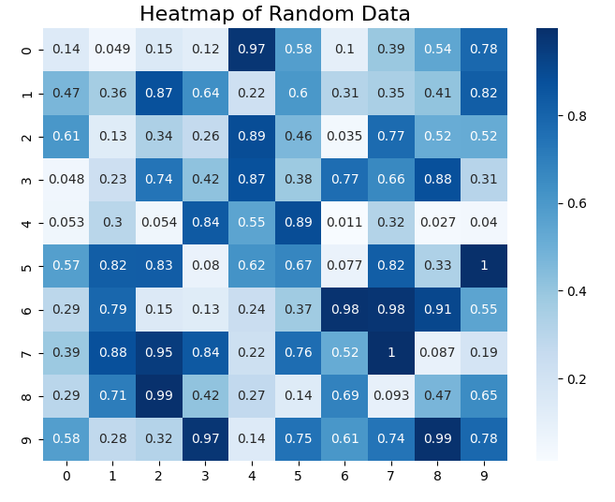

Through this project, we leveraged the power of machine learning in analyzing medical data, contributing to the development of innovative solutions for early diagnosis, which significantly improves patients' lives.

Although the results obtained were excellent, the model still requires further improvements to increase its accuracy in certain ambiguous or unclear cases. Additionally, the dataset used did not include all possible patterns of skin diseases, which may affect the model's ability to generalize to unseen cases.

Final Remarks
Over time, it will be crucial to enhance the model to handle a wider variety of images. The system can also be developed to include additional layers of AI to improve the user experience and make the system more interactive. 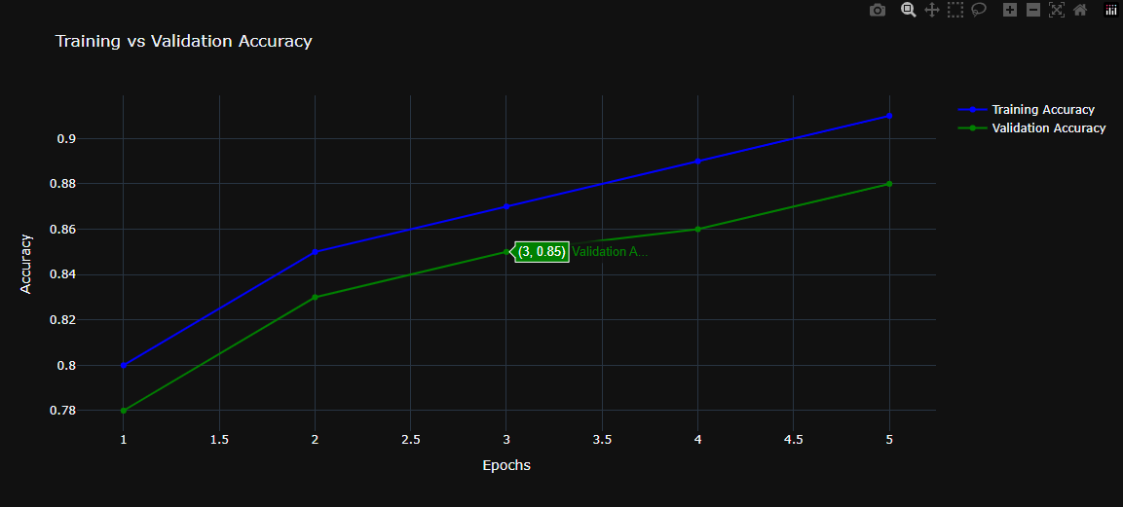

Future Work

In the future, we aim to develop the system to include several advanced features that can make the experience more interactive and realistic. Some of these features include:
Adding a Chatbot: We will develop an intelligent chatbot that can interact with users via text or voice. The chatbot will be able to understand the user’s emotions based on their queries. If the user feels anxious about the disease, the chatbot will reassure them and provide tips on managing the condition. If the user is indifferent or unaware of the disease, the chatbot will provide more detailed information about the consequences of neglecting treatment.

Augmented Reality (AR): We will integrate Augmented Reality (AR) technology into the system, allowing users to send an image of the disease for analysis and predictions about their health condition. For example, if the condition requires immediate treatment, the system will alert the user about the potential consequences of delaying treatment.

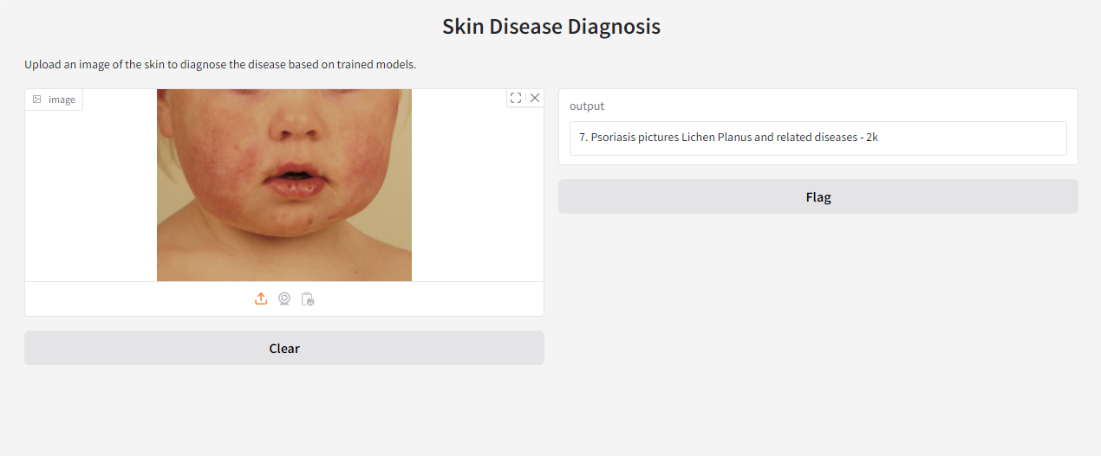
Voice Interaction: A voice interaction feature will be developed in the system, allowing users to interact with the model via voice. The model will also be able to respond with voice, enhancing usability and making the process more interactive.

Smart Camera: A smart camera function will be added to the system, allowing real-time interaction with the user. When the user sends an image of the condition, the system will guide them on how to adjust the camera or change angles to capture the best possible image of the disease. This will contribute to improving diagnostic accuracy by ensuring clear images are captured.

By incorporating these future features, the system will become more integrated with the user's needs and will enhance its ability to predict skin diseases, assisting doctors in making faster and more accurate decisions.

References
The references and sources used in the preparation of the previous parts of the research are:

- Ultralytics. (n.d.). Convolutional Neural Network (CNN). Retrieved from https://www.ultralytics.com/ar/glossary/convolutional-neural-network-cnn
- MDPI. (2023). The Use of Artificial Intelligence for Skin Disease Diagnosis. Healthcare, 12(12), 1192. Retrieved from https://www.mdpi.com/2227-9032/12/12/1192
- PeerJ. (2023). AI in dermatology: a comprehensive review into skin cancer detection. PeerJ Computer Science, 9, e2530. Retrieved from https://peerj.com/articles/cs-2530/
- Easiio. (n.d.). Convolutional Neural Networks. Retrieved from https://www.easiio.com/ar/convolutional-neural-networks./
- AWS. (n.d.). What is a Neural Network? Retrieved from https://aws.amazon.com/ar/what-is/neural-network/
- Liu, Y., et al. (2020). Deep learning for dermatologists: A comprehensive review of dermatology applications. Medical Image Analysis, 64, 101706. Retrieved from https://www.journals.elsevier.com/medical-image-analysis
- Esteva, A., et al. (2017). Dermatologist-level classification of skin cancer with deep neural networks. Nature, 542, 115–118. Retrieved from https://www.nature.com/articles/nature21056
- Haenssle, H. A., et al. (2018). Artificial intelligence in dermatology: Current status and future directions. Journal of Investigative Dermatology, 138(11), 2331-2339. Retrieved from https://www.jidonline.org/article/S0022-202X(18)30665-5/fulltext
- Gandhi, T., et al. (2020). AI in skin disease diagnostics: From theory to practice. Journal of Dermatological Science, 98(3), 125-132. Retrieved from https://www.jdsjournal.com/

- Kermany, D. S., et al. (2018). Identifying medical diagnoses and treatable diseases by image-based deep learning. Cell, 172(5), 1122-1131.e9. Retrieved from https://www.cell.com/cell Salah Eldin

